Training Schedule Design Notes

Introduction

Each client has their own set of training schedules, created for them by their *Coach*, also referred to as a *Trainer*. A schedule is usually referred to as a *Block,* where a block is defined as a set of multiple *Training Sessions*, executed in the gym or other location, that build towards a pre-defined strength goal for that client. One week in a Block is called a *Microcycle*. Blocks are spread over a number of weeks that fit the client’s availability and abilities. Trainers can adjust the number of weeks or range of exercises as the block progresses if necessary.

During a training session, a client executes a number of different *Sets*. A set is a series of movements or execises that can be repeated in sequence. An example of a set could be sequence of five movements shown below. The client starts with the weights on the ground, begins the lift to their shoulders, squats and raises the weights above their head, then stands and lowers the weights to their shoulder height, finally lifting it above their head.

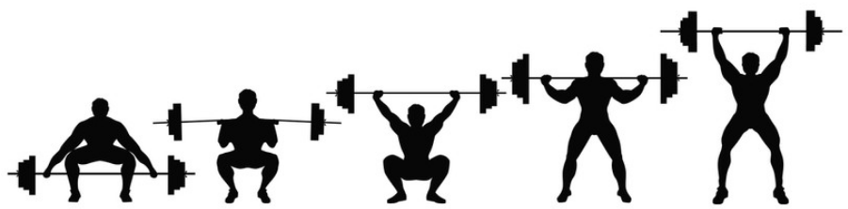

A *Rep* is defined as a repeat of the same movements shown above in the same order. A Set is therefore a sequence of movements that can be repeated a predefined or scheduled number of times. Each gym session is therefore made up of a number of sets, each with a specified number of reps for that set. Each set in a session follows logically from the previous one with appropriate rests in between sets.

Example spreadsheet

<https://docs.google.com/spreadsheets/d/1MdPu7sEBivl--HO4X8t6Hr8JFhtry_-UoGHSyxtx4RI/edit?gid=2125202489#gid=2125202489>

How Sex, Strength, and Age Affect Strength Gains In Powerlifters

https://www.strongerbyscience.com/predict-strength-gains/